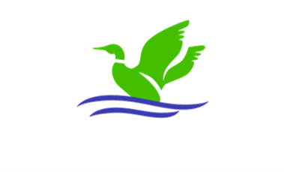

<Date>

<Homeowner Name>
<Address>
Knoxville, TN 37922
Re: Courtesy Notice- HVAC>

Dear Homeowner:

One of the signature features of Mallard Bay are the exterior standards. They provide a uniform look and community feel for the neighborhood. To maintain that image, we want to work with our neighbors to ensure compliance & conformity.

Pursuant to the Mallard Bay Declaration of Covenants and Restrictions, HVAC equipment shall be screened by fencing or planting. Please see Article XIII, Section 16: (i) below.

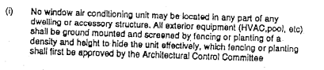

Thank you in advance for your attention to this matter.

Should you have any questions or concerns, please contact Dewayne Topping at Realty Resource Systems (our management company.) His contact information is dewayne@realtyresourcesystems.com or 865-584-9099 Ex 3.

Sincerely,

Board of Directors
Mallard Bay Homeowners Association

cc: file

